**NAME – KHUSHI PANWAR, khushipanwar26@gmail.com**

**ROLL NO – 2021334**

**CSA PRACTICAL: ASSIGNMENT 4**

1. **Write an assembly language program for simulating following memory reference instructions using INDIRECT ADDRESSING:**
2. 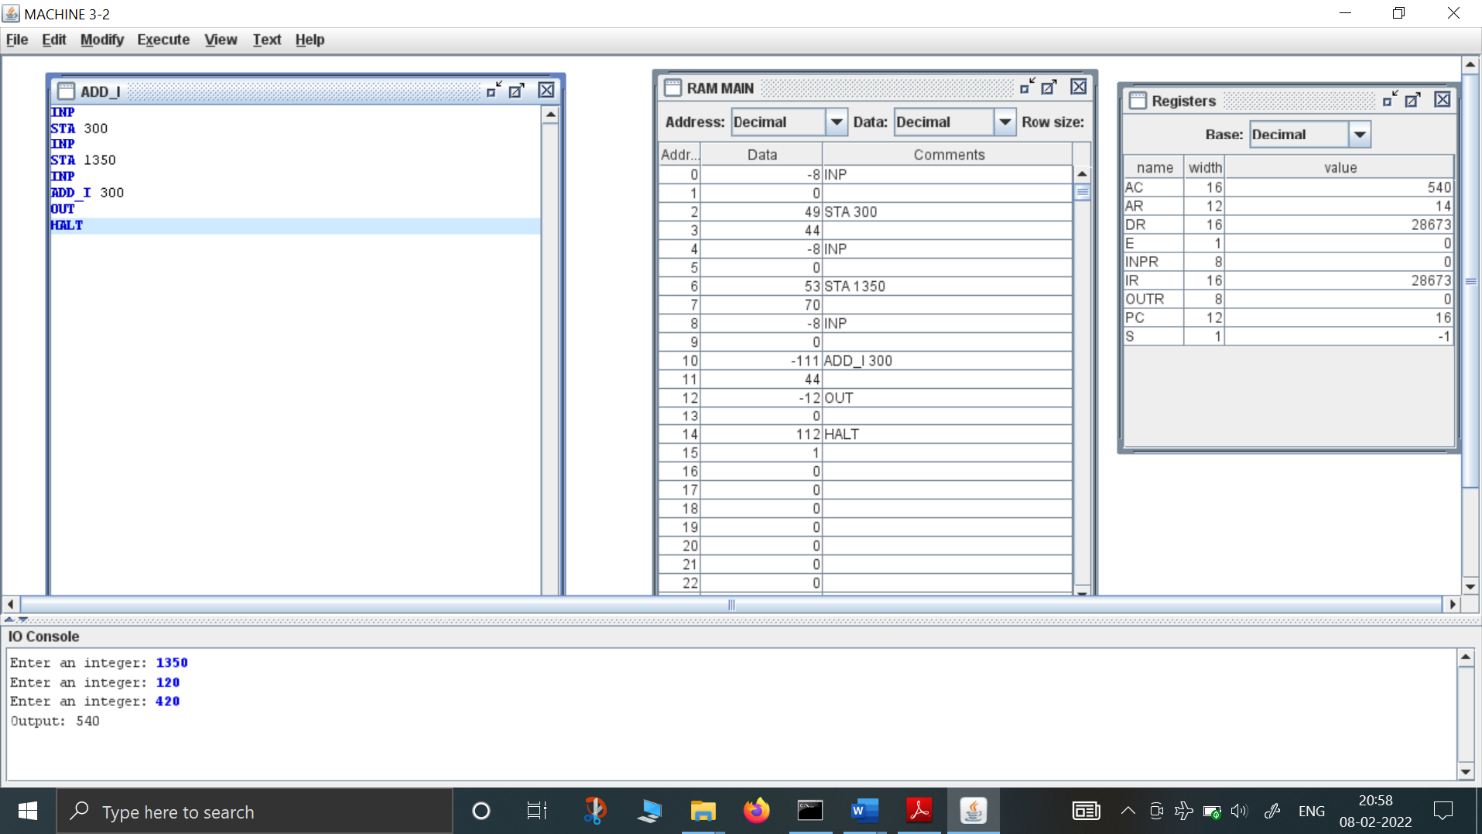**ADD_I**
3. 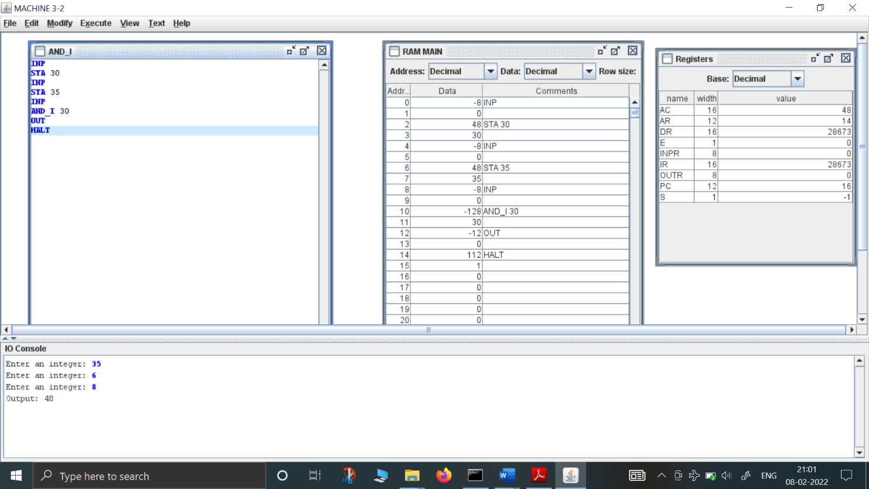**AND_I**
4. 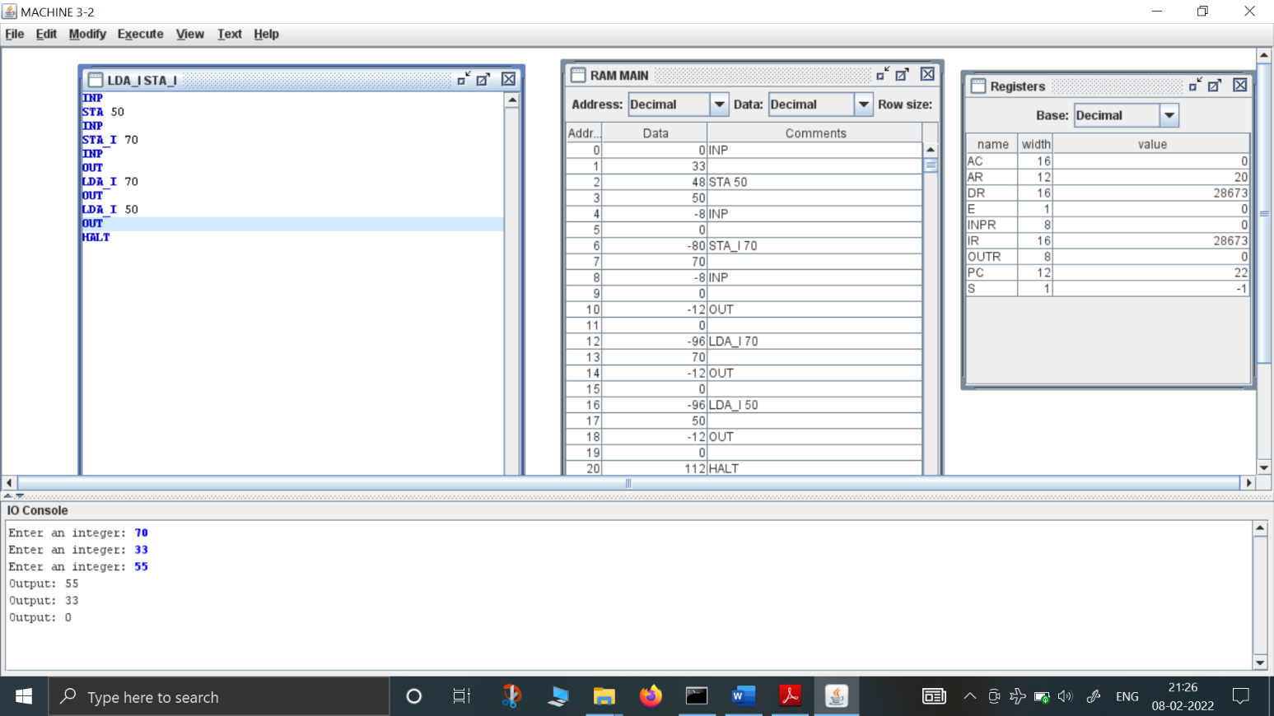**LDA_I**
5. 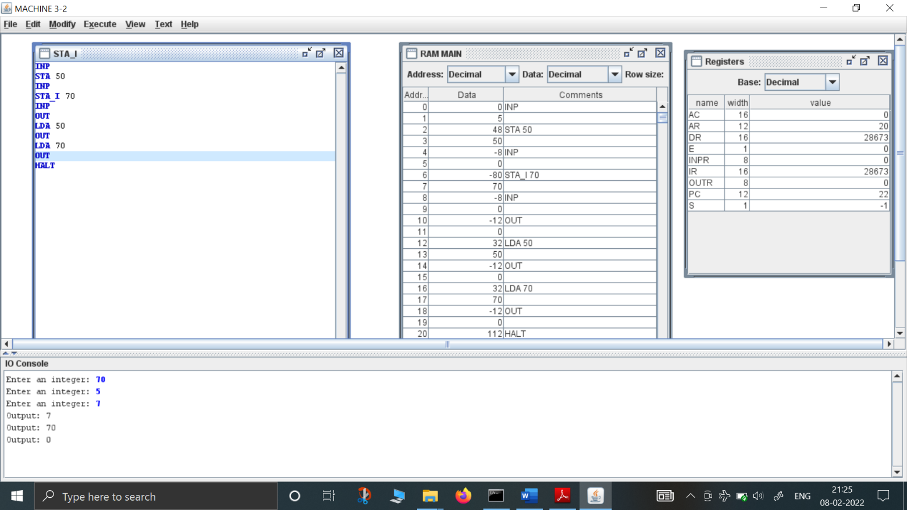**STA_I**
6. **BUN_I**

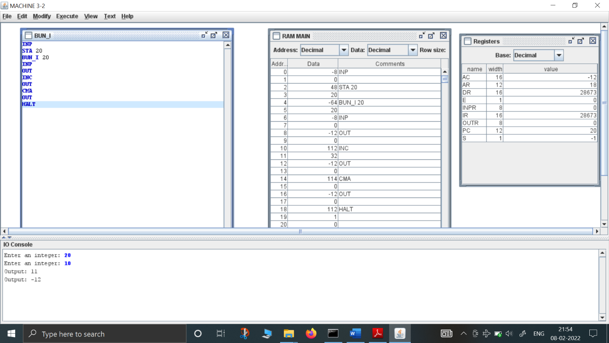

1. 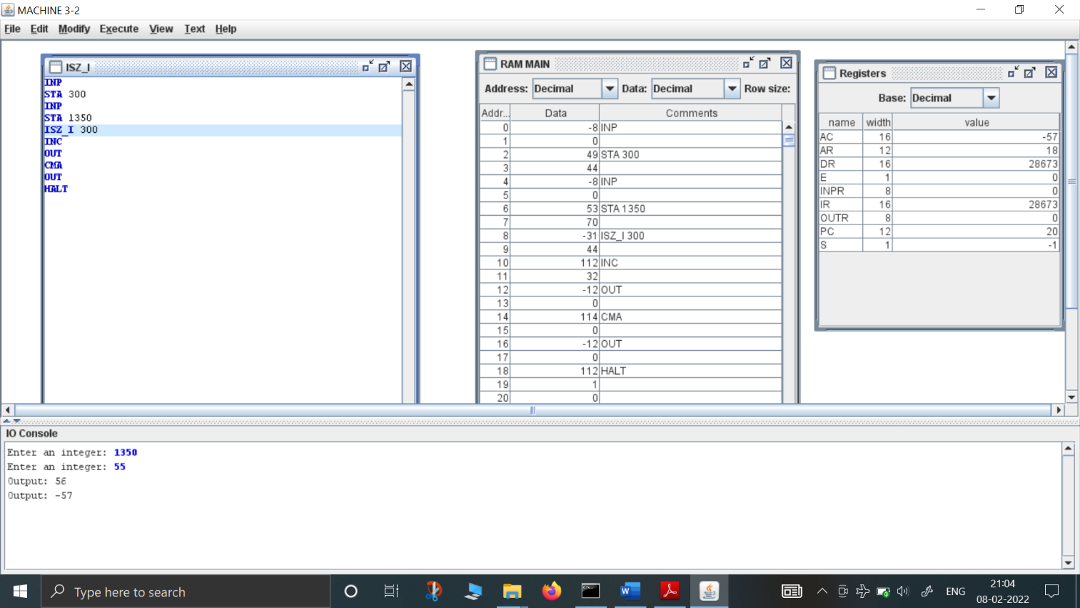**ISZ_I**
2. 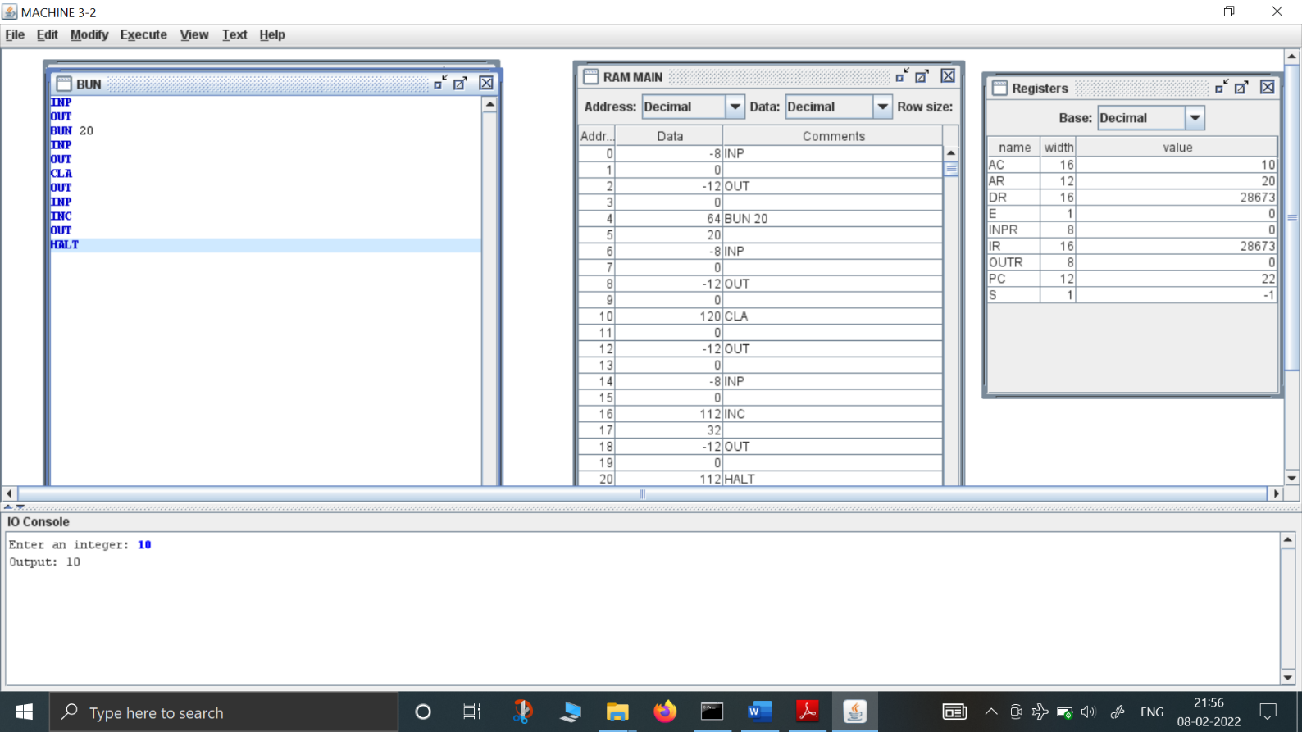**Write an assembly language program for simulating BUN instruction (memory reference) :**